**Sprint 2 Accuracy Design Document**

**Executive Summary**

***Project Overview***

**Describe this project or product and its intended audience, or provide a link or reference to the project charter.**

**The idea of this project is to use our coding and software engineering skills to control a robot, and make the robot follow the steps that were provided. This is intended to reach the audience of the rest of our class and professor Eckert.**

**Purpose and Scope of this Specification**

The purpose of this project is to have our robot complete a figure 8 on the ground in the classroom with very specific instructions on where to go and when to go there. It will be presenting its accuracy to professor Eckert. All of the instructions for the robot to complete the activity correctly will be listed within the scope

**Product/Service Description**

The general factors that affect the product and its requirements are the code that we write and any outside factors such as chairs, tables, and the wall. Also the robot itself, if it is damaged or broken it may not be used correctly. All of these factors are the reasons why we have these specific requirements.

***Product Context***

We are using the Sphero coding system in order to control our robot and make it follow the specific instructions it gives. The Sphero robot is unique because of its spherical design and advanced programming capabilities, setting it apart from traditional robotics products. As a self-contained device, Sphero operates independently. Sphero has compatibility with a variety of related systems, enabling users to interface with smartphones, tablets, and other devices through Bluetooth connectivity, giving lots of versatility for coding and controlling the robot. The major components of Sphero would include its spherical body, internal sensors, motors, and the programmable interface, all combined to give communication and control.

***User Characteristics***

There will be three of us working on the project. We are all new to coding and have used the Sphero system only 1 or 2 times before. Hopefully we can learn the best way to use Sphero by doing the project and learn as we go along.

***Assumptions***

* Inserting inaccurate speed into block code
* Inserting inaccurate distance into block code
* Inserting inaccurate angles into block code
* Not having access to the room
* Tables and chairs interfering with robot
* Damaged equipment
* Sphero, laptop, or smartphone out of battery

***Constraints***

* Room availability
* Due date
* Resources

***Dependencies***

* Code must be written in block
* Code must be completed for the robot to run
* Room must be available
* Robot must be charged
* Phone and laptop must be charged
* Robot and bluetooth must be working properly

***Accuracy***

1. There will be a piece of tape on the floor of the classroom that the robot must follow

2. We will begin by placing the robot at the starting point

3.Once placed on the starting point the robot will turn blue and begin

4. The robot will loop 5 times

5. It will spin at a speed of 115, 360 degrees. for 6 seconds

6. It will then stop

7. It will spin at a speed of 110, -360 degrees, for 6 seconds

8.Speak “I am the winner ”

9. It will then begin to rapidly switch colors

***Functional Requirements***

| Req# | Requirement | Comments | Priority | Date Rvwd | SME Reviewed / Approved |
| --- | --- | --- | --- | --- | --- |
| 1 | There will be a figure 8 shaped course in the classroom that the robot must follow, based on our code. | The robot is sometimes affected by chairs and an outlet on the floor |  | 11/12/23 | Approved |
| 2 | The robot will begin by glowing blue a | Meets requirement |  | 10/12/23 | Approged |
| 3 | Robot will spin 360 degrees for 6 seconds at a speed of 115 | Meets requirements |  | 11/12/23 | Approved |
| 4 | The Robot will stop | Meets requirements |  | 10/12/23 | Approved |
| 5 | The robot will then make a -360 degree turn at a speed of 110 for 6 seconds | Meets requirements |  | 11/12/23 | Approved |
| 6 | The robot will stop | Meets requirements |  | 11/12/23 | Approved |
| 7 | The robot will repeat that loop 5 times | Meets requirements |  | 11/12/23 | Approved |
| 8 | The robot will stop | Meets requirements |  | 11/12/2/3 | Approved |
| 9 | The robot will speak “I am the winner | Meets requirements |  | 11/12/2/3 | Approved |
| 10 | The robot will then being to change colors | Meets requirements |  | 11/12/2/3 | Approved |
| 11 | The Robot must not collide with any objects. | Meets requirements |  | 11/12/2/3 | Approved |

***Security***

***Protection***

There is one person who is in sole possession of the robot. They are not allowed to give it to any other group members to prevent losing it or miscommunications. The person who possess the robot signed off on it to ensure they do not lose it and are in full responsibility

***Authorization and Authentication***

In order to access the Sphero app you must have a device that is compatible and you must have an account.

**Portability**

| **Meeting Date** | **Attendees (name and role)** | **Comments** |
| --- | --- | --- |
| **11/12/23** | Salvatore, David, Deuce | **confirmed all** |
| **11/20/23** | Salvatore,David,Deuce | **confirmed all** |
|  |  |  |
|  |  |  |

***System design***

***Algorithm***

* Place the robot on the starting point
* Robot turns on Blue light
* Robot spins at an angle of 360 for 6 seconds, at a speed of 115
* Robot spins at an angle of -360 for 6 seconds, at a speed of 110
* Repeat steps 2-4 in a loop
* stop
* Speak “I am the winner”
* Robot begins to flash colors for 5 seconds

***System Flow***

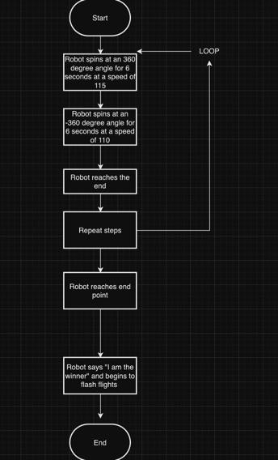

***Software***

Describe software languages/platforms/api’s used to develop and deploy this application. Embed your block code here

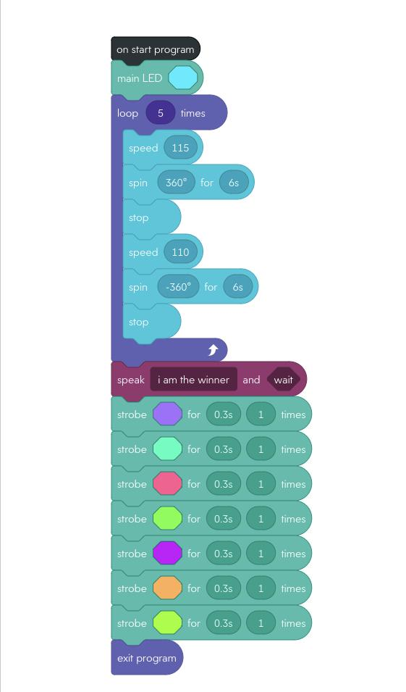

***Hardware***

Laptops and phones were used

***Test Plan***

Include a test plan showing all unit tests performed for this application, Include test rational, test date, staff member, pass/fail status

| **Reason for Test Case** | **Test Date** | **Expected Output** | **Observed Output** | **Staff Name** | **Pass/Fail** |
| --- | --- | --- | --- | --- | --- |
| To get data for the project | 11/12/23 | The go in circle on the line | Made a circle but did not follow the line | Sal | fail |
| Test 120 speed | 11/12/23 | To have an appropriate speed to conduct the experiment | Was too fast had to slow it down | Sal | fail |
| Test 110 speed | 11/12/23 | To have an appropriate speed to conduct the experiment | Worked well, made a well rounded circle | Sal | fail |
| Test -360 degree rotation | 11/12/23 | To make a circle going in the opposite direction to make an 8 | Worked well made a shape similar to an 8 | Sal | pass |
| Stop at start point | 11/12/23 | For Sphero to stop where it started | Stopped relatively close to where it started | Sal | pass |
| Say “I'm the winner” | 11/12/23 | To show we have a good understanding of the Sphero block code | Said “I'm the winner” | Sal | pass |
| Change colors | 11/12/23 | To show we have a good understanding of the Sphero block code | Changed colors | Sal | Pass |
|  |  |  |  |  |  |
|  |  |  |  |  |  |
|  |  |  |  |  |  |
|  |  |  |  |  |  |

***Task List/Gantt Chart***

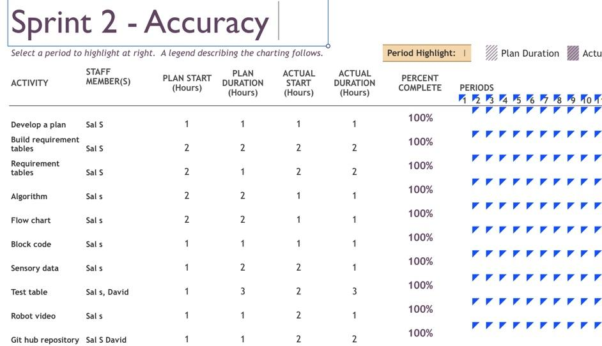

***Staffing Plan***

**Insert a chart/table that depicts the roles and responsibilities of each team member that worked on this project**

| **Name** | **Role** | **Responsibility** | **Reports To** |
| --- | --- | --- | --- |
| Sal | Logged all information into the charts and the document | Diligently checked the numbers on the code and the moved them to document | David |
| David,Sal | Trial and error process of the robot | Wrote the code and made observations |  |
| Deuce |  |  |  |